Team WORK Milestone 7

CSCI 3308 Spring 2018

*Project Title:* Natural Neighbors

*Group Members:*

* Joy Mace
* Jacob Bloom
* Jun Sheng
* Elliot Ishak
* Tuqa Alaithan
* Robert Rossetti

*Project Tracker*: Trello (Kanban)

*Trello Link:* <https://trello.com/b/yHYdhQwc/natural-neighbors>

#### Trello Screenshot:

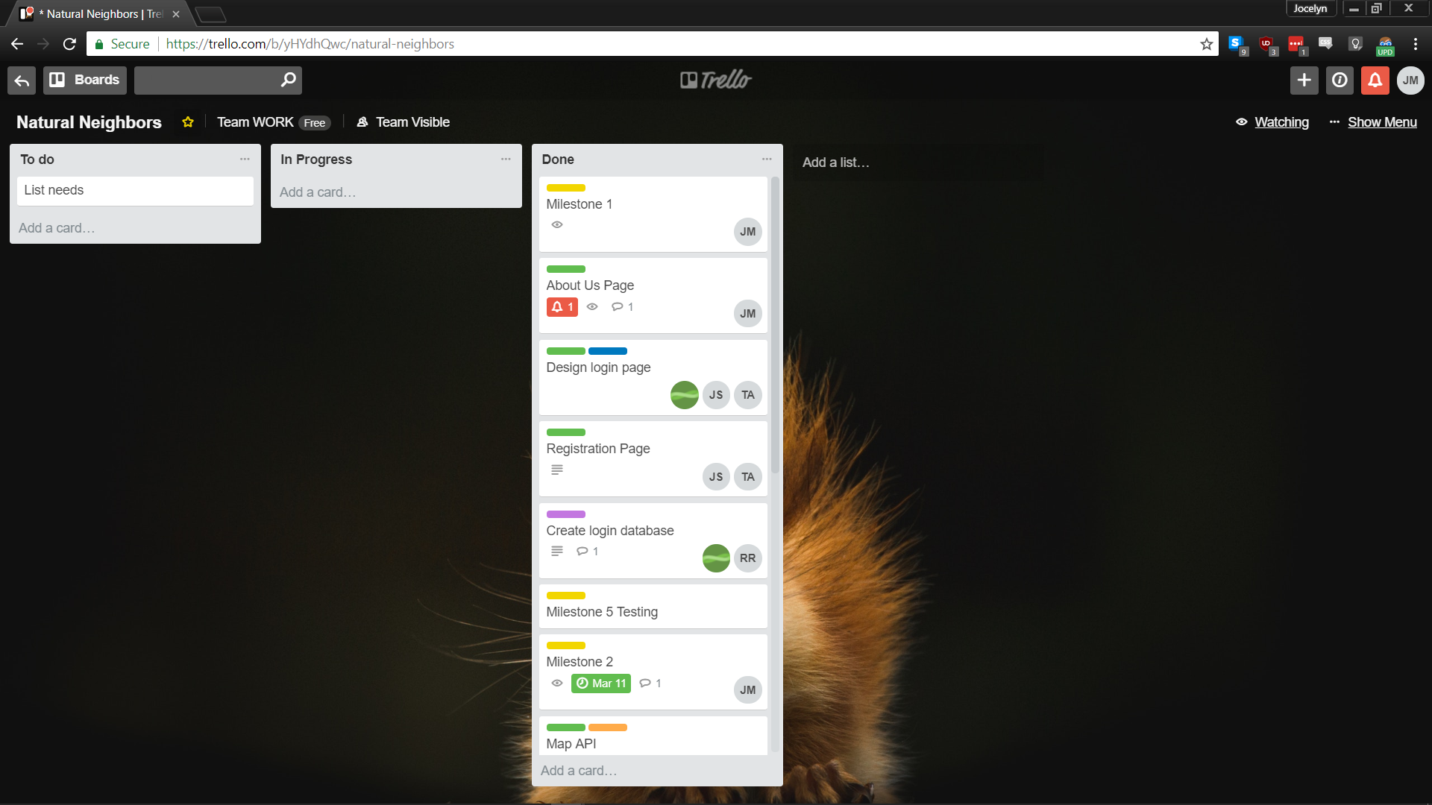

*Video Demo:* <https://www.youtube.com/watch?v=MBrT0ZcP6OE>

*GitHub link:* <https://github.com/mrjacobbloom/teamWORK>

#### Team member commits screenshot:

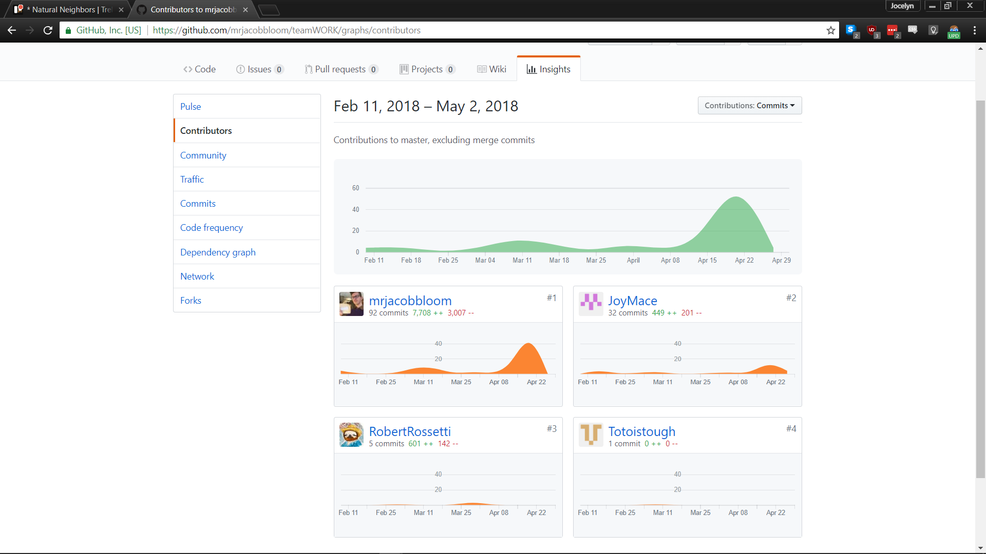

#### Eliott and Jun worked on the Presentation:

Everybody tweaked it.

We went through 3-7 logo iterations. First by Eliott, then Tuqa, then Jacob finalized the design.

**Deployment Link:** <https://natural-neighbors.herokuapp.com/>

*See README on repo for organization/structure information and remaining items.